JOEL WYN TAN & VUTHY YI

Data visualisation project

Table of Contents

Introduction 2

Background and Motivation 2

Visualisation Purpose 2

Project schedule 3

Data source 3

Data Processing 4

Visualisation Design 4

Progress 8

Reference 11

Appendices 12

# Introduction

## Background and Motivation

The evolution of electricity starts dated back to 1752 when Benjamin Franklin uses a kite during a thunderstorm to prove that static electricity and lighting were the same thing. Electric current is always part of nature, and we are slowly moving toward the age of generating through coal, nuclear power, and various way to evolve toward current day where we are heavily relying on electricity for our daily life. However, these convenience does come with a cost such as air, water pollutions. In Australia, air pollutions would be one of the major concerns from generating electricity. As we evolve, renewable power options have also become more viable and cost-effective options for many Australian. For our future generations, it is important for us to acknowledge the climate emergency and start looking into more sustainable power options. Solar power is one of the very accessible options for public with various government fund supporting to reduce the cost of installations. It is important for the public to understand how much they could contribute and change the way power is generated. Besides reducing gas emissions from coal generated power, using solar power also help saving money on power from a renewable energy.

## Visualisation Purpose

The purpose of our visualisations is to give the public a clear view of the increases of renewable energy throughout the last few years, and the cost saving from having a solar system at home. We will also have a visualisation of the increases of cost from buying energy from retailers during peak and non-peak time, and how much it has increases from last few years. Furthermore, having a correlation of how much we reduced in greenhouse gas emissions with the increase of solar power installed also give the users a certainty that they are contributing to a more sustainable climate. Combining all the visualisations, we can clearly see the benefits of using solar power not only reduce gas emissions, but it also reduce the electricity bills for many household. Eventually, many peoples have also learnt to use and power their high electricity consumptions electronics during the daytime where the solar panel is on the full run.

## Project schedule

Week 3 – gathering data, information and topics

Week 5 – start on the introductions

Week 7- brainstorming how we going to code the visualisations

Week 9- starting to code the visualisation

Data

# Data source

We are gathering our data from various sources

For solar installations in Australia, we gather the data from Australia PV Institute and the data is in CSV

<https://d3hysioybks0ok.cloudfront.net/attachments/analysis/10/monthly_analysis_data_4f10.csv>

For greenhouse gas emissions data, we gather it from department of science, energy and industry and the data is in xlsl.

<https://www.industry.gov.au/data-and-publications/national-greenhouse-gas-inventory-quarterly-update-september-2021>

For wholesale price of electricity, we gather it from Australian energy regulator in CSV

https://www.aer.gov.au/wholesale-markets/wholesale-statistics/annual-volume-weighted-average-30-minute-prices-regions

## Data Processing

Few of our dataset comes with many states or more than 10 years, we will do few data splitting and on extracting the data that meet our requirements, so the visualisations are not over cluttered.

Requirements

Features

Having the options to see how different states in Australia is doing, also like to implement a geo mapping with how it changes to more solar power throughout the last three years.

## Visualisation Design

We plan to display a geo-mapping with colour hues that highlight how each state has changed from the red colour which is low in solar power toward yellow and then green as there is more solar power allocation. As for the cost of electricity, we will display it with a bar chart. We will use a line chart to visualise e the decrease in greenhouse emissions.

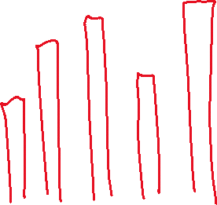

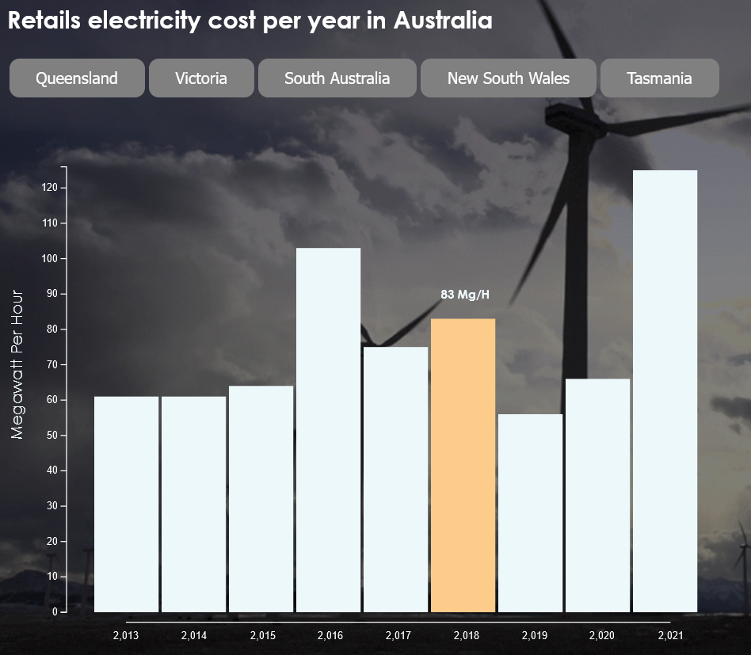

Figure 1.Bar Chart Describing the Retail Electricity Cost Per Year In Australia

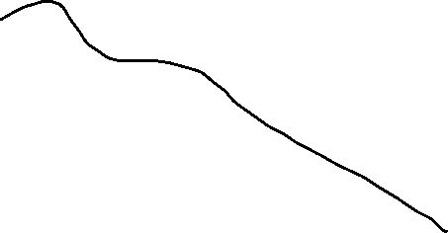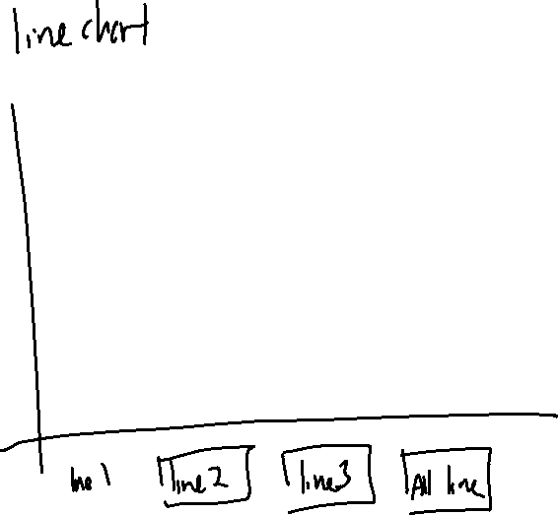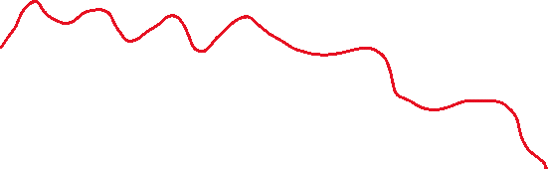

Figure 2. A Line Graph Describing the Green House Emission Level

Figure 3. An Early Look of The Geo Map of Australia

# Progress

Initially, we planned to build a simple bar chart to showcase the data of cost of electricity with button to choose for different states. We improved the bar charts with hover to show the actual data when mouse over.

We have improved our buttons for both the bar chart, and we have plans to add an active class on the buttons that we hover our mouse over. Further changes for the colouring of the labels will be made for better visibility.

Our plan to implement the line chart is to be able to have the trend line, emission line, and seasonal line using the data on greenhouse emissions. Initially, we thought of using a loop and split the data to output into a new CSV to clean the data before using it, but after talking to Afzeel, we decided to focus more on the actual visualisation and clean up the data manually.

From

to

We were planning to have 4 button where first 3 buttons transform each line between emissions, trend and seasonal while the fourth button display all 3 lines. I’ve tried using select path with path id for particular path to apply on mouse click but the implementation outcome failed. Further research needed to make it works.

The Choropleth is functional with the new geojson file (aust.json), but it is yet able to accept data inputs. Additionally, it is worth noting that the aust.json file is rather problematic to work with as it is old. However, a more up to date alternative has been found with the australian-states.min.geojson file. We are still trying to figure out how to work with it. More data would be useful for the geo map as our current datasets have proven to be rather incompatible with our vision of the heat map.